**Project:Three Stages CI/CD Pipeline to deploy application code in multiple AWS Region**

The project involves setting up a three-stage CI/CD pipeline to deploy a given application in multiple AWS Region. The pipeline will utilize:

1. **AWS CodeCommit** for source code management and version control.
2. **AWS CodeBuild** to build the code and run tests.
3. **AWS CloudFormation** as the deploy provider to provision and manage the infrastructure

Diagram

This pattern's multiple-Region architecture and workflow comprise the following steps.

1. You send your code to a CodeCommit repository.
2. Upon receiving any code update or commit, CodeCommit invokes a CloudWatch event, which in turn starts a CodePipeline job.
3. CodePipeline engages the CI that is handled by CodeBuild. The following tasks are performed.
   * Testing of the AWS CloudFormation templates
   * Packaging of the AWS CloudFormation templates for each Region included in the deployment. For example, this pattern deploys in parallel to three AWS Regions, but for demo purpose we will do two is this project. so CodeBuild packages the AWS CloudFormation templates into two S3 buckets, one in each specified Region. The S3 buckets are used by CodeBuild as artifact repositories only.
4. CodeBuild packages the artifacts as input for the next Deploy phase, which runs in parallel in the two AWS Regions. If you specify a different number of Regions, CodePipeline will deploy to those Regions

Screenshot of the CICD Pipeline from the console

Stack created in the first region (us-east-1)

Application Code successfully deployed to east 1

Stack created in the 2nd region (us-west-1)

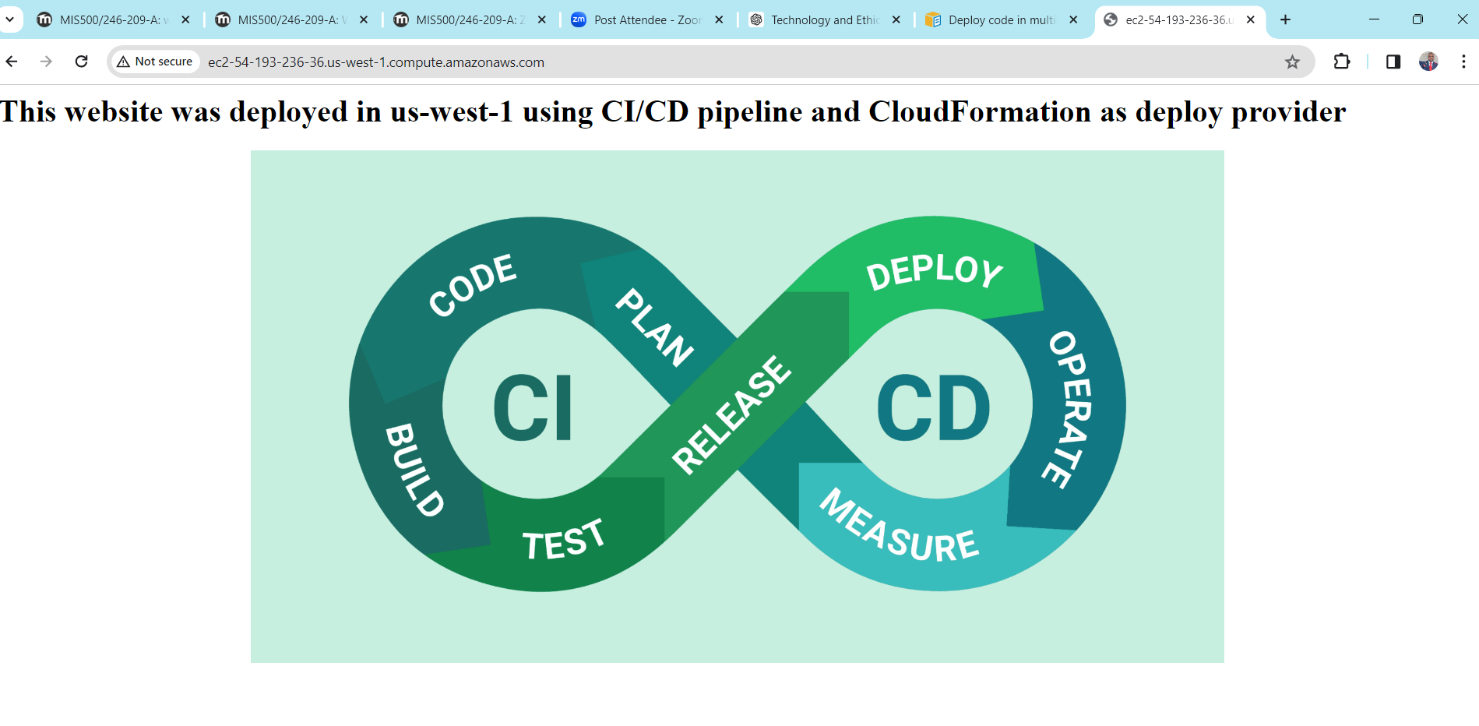Application Code successfully deployed to east 1